Selenium Automation Testing Frameworks
Objective: To be able to proceed with automation techniques using Selenium by Python
Tools:
- Python 3.10.0
- Selenium 4.47.0
Concepts Used:
- Using Locators
- Debugging Errors – Element not found
- Multiple Matching Element
- Locating Links and Tables
- Checkboxes
- Radio Buttons
- Multi Select Box
- is_Enabled()
- get_attribute, location
- Webpage Navigation
- Modal Windows
- Window Handles
- Taking Screenshots
- Tables
- Keyboard Actions
- Drag Drop
- Cross Browser
- Chrome and Firefox
- PhantomJS
- Maven
LOCATORS
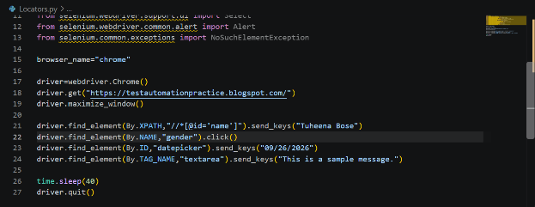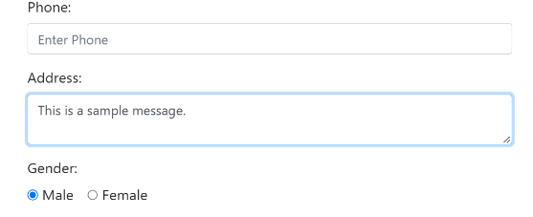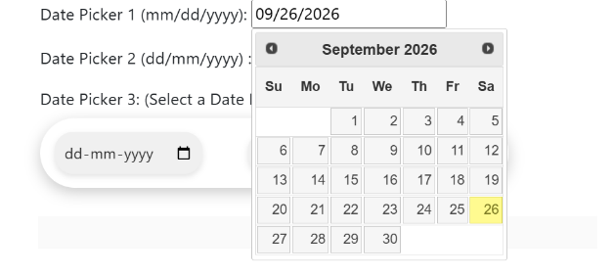

ERROR HANDLING
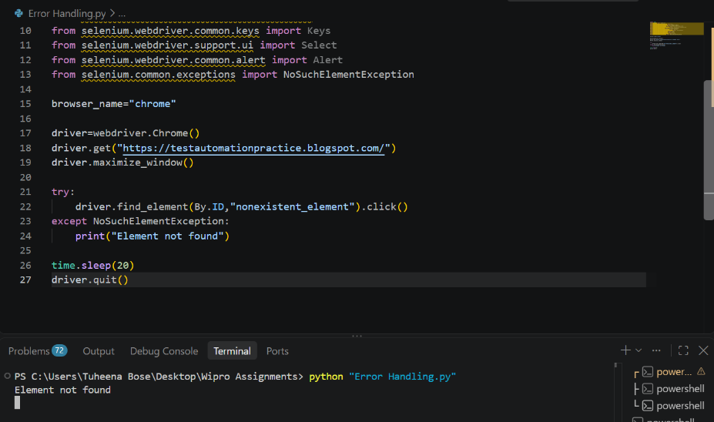
MULTIPLE MATCHING ELEMENT
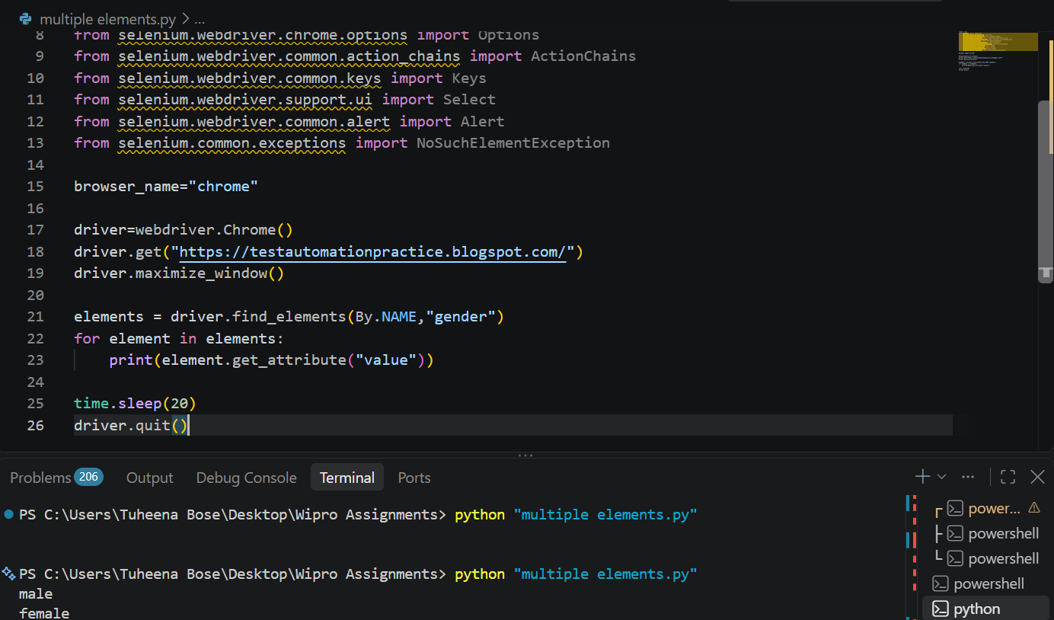
LOCATE LINKS AND TABLES
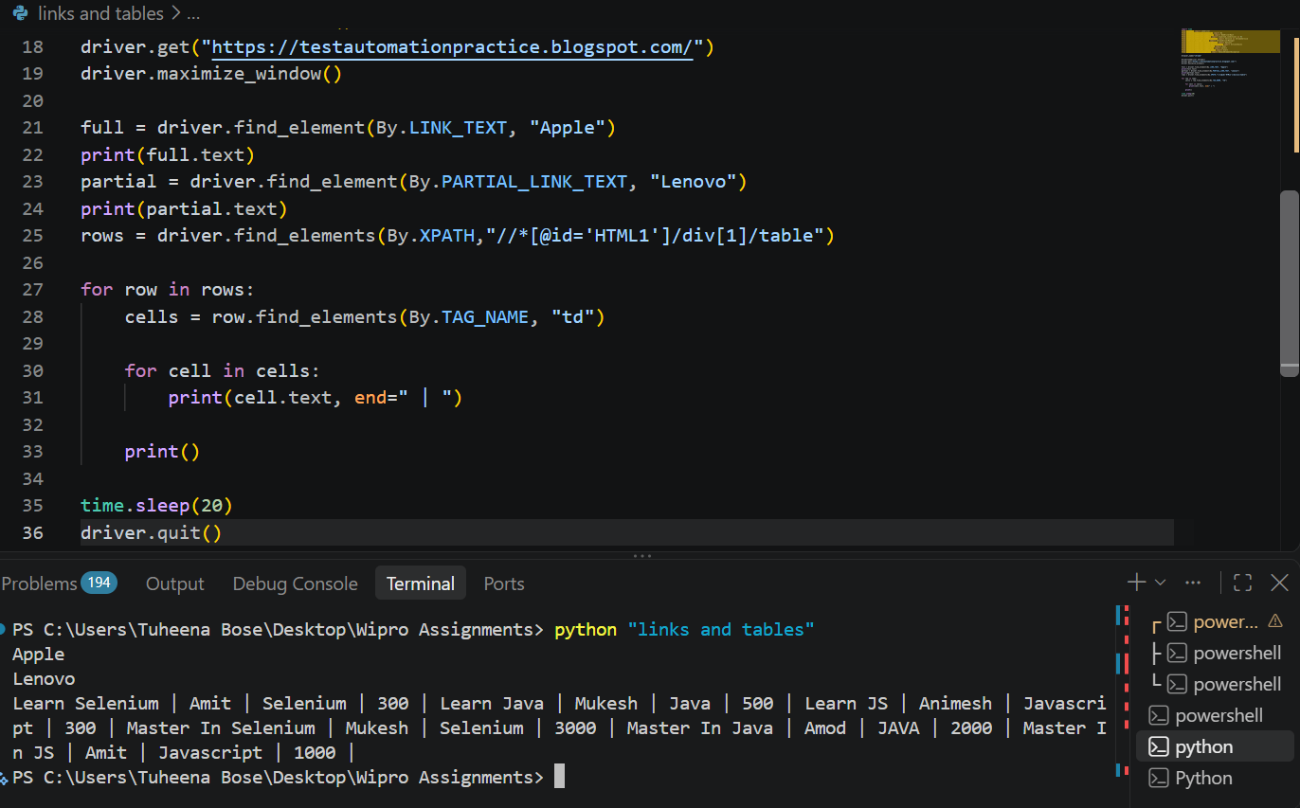
CHECKBOXES AND RADIOS
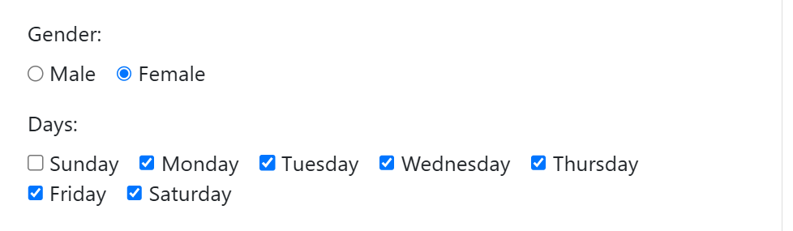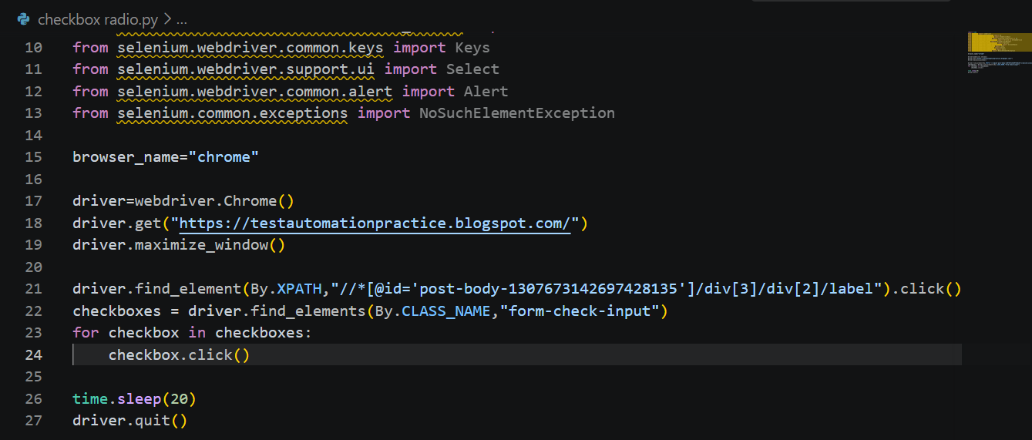

DATA DRIVEN
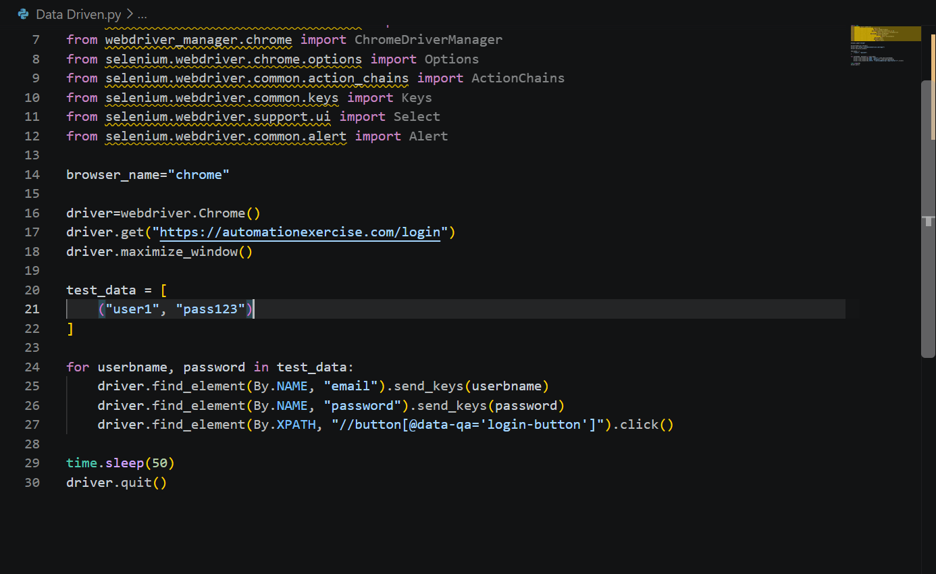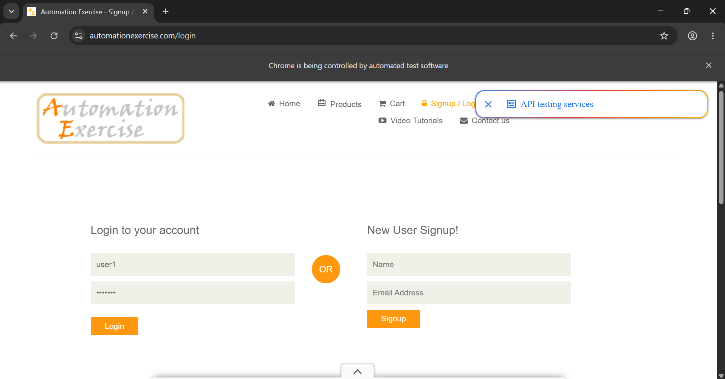
is_enabled()
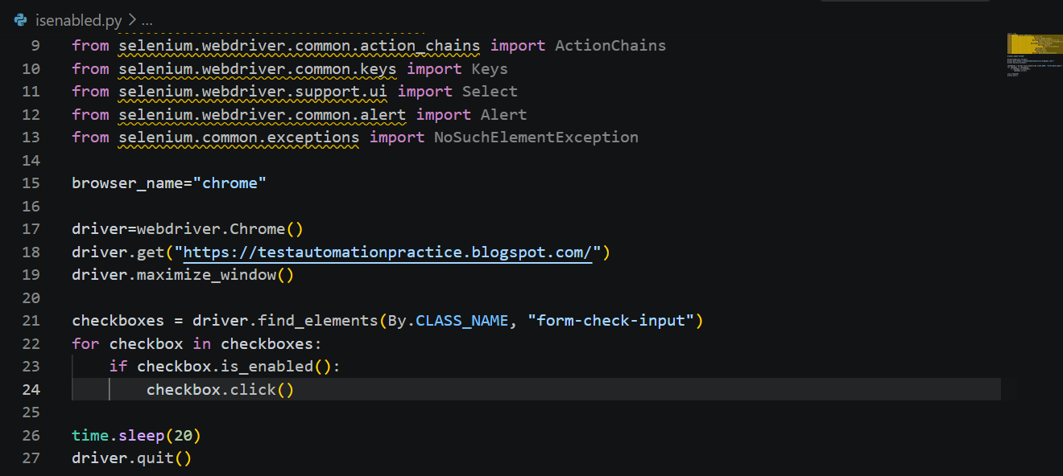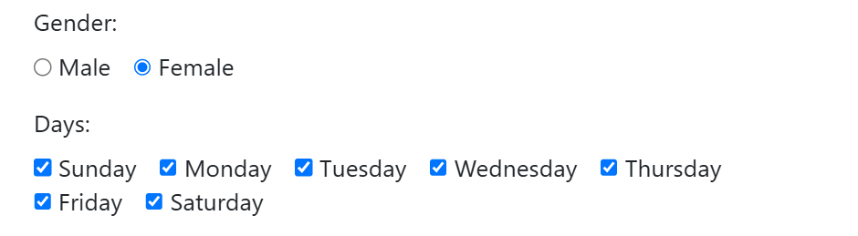

getAttribute and location()
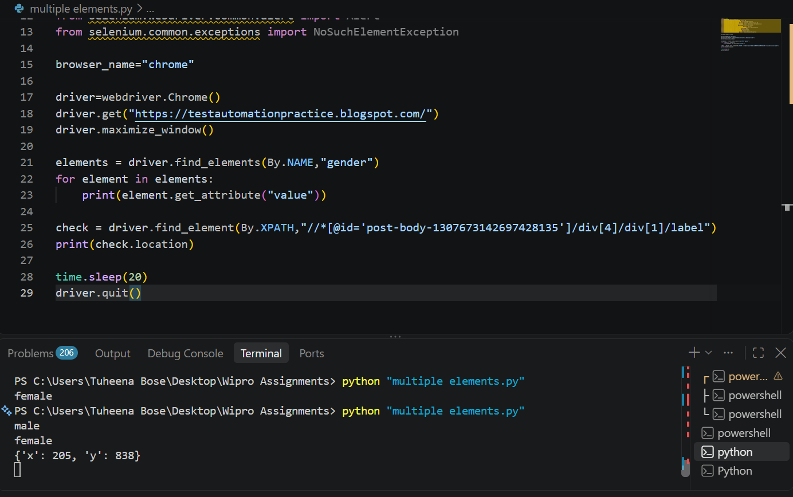
NAVIGATION
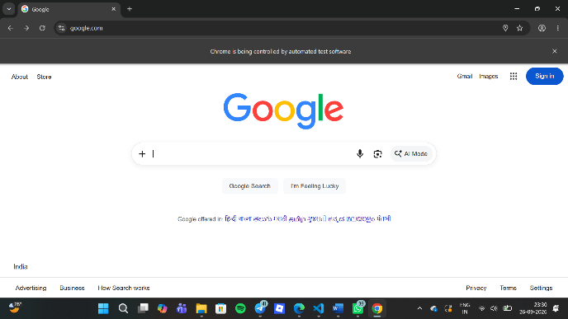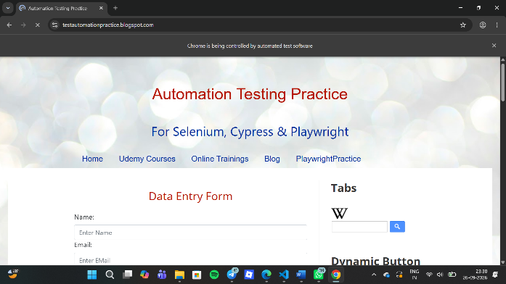
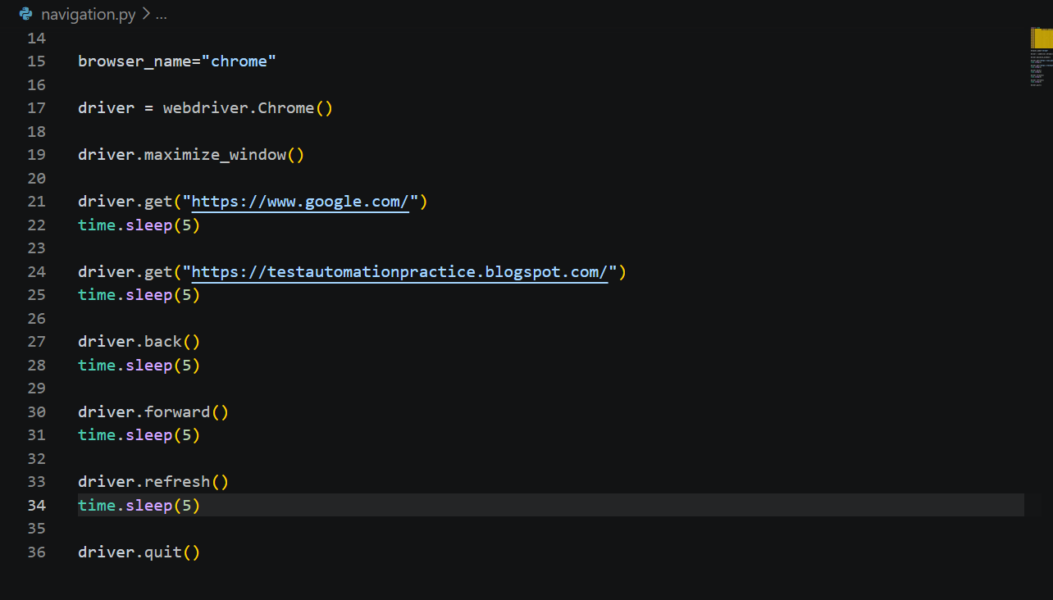
WINDOW HANDLES
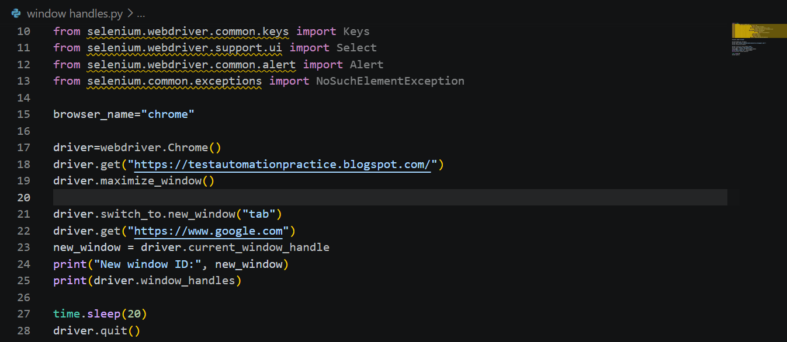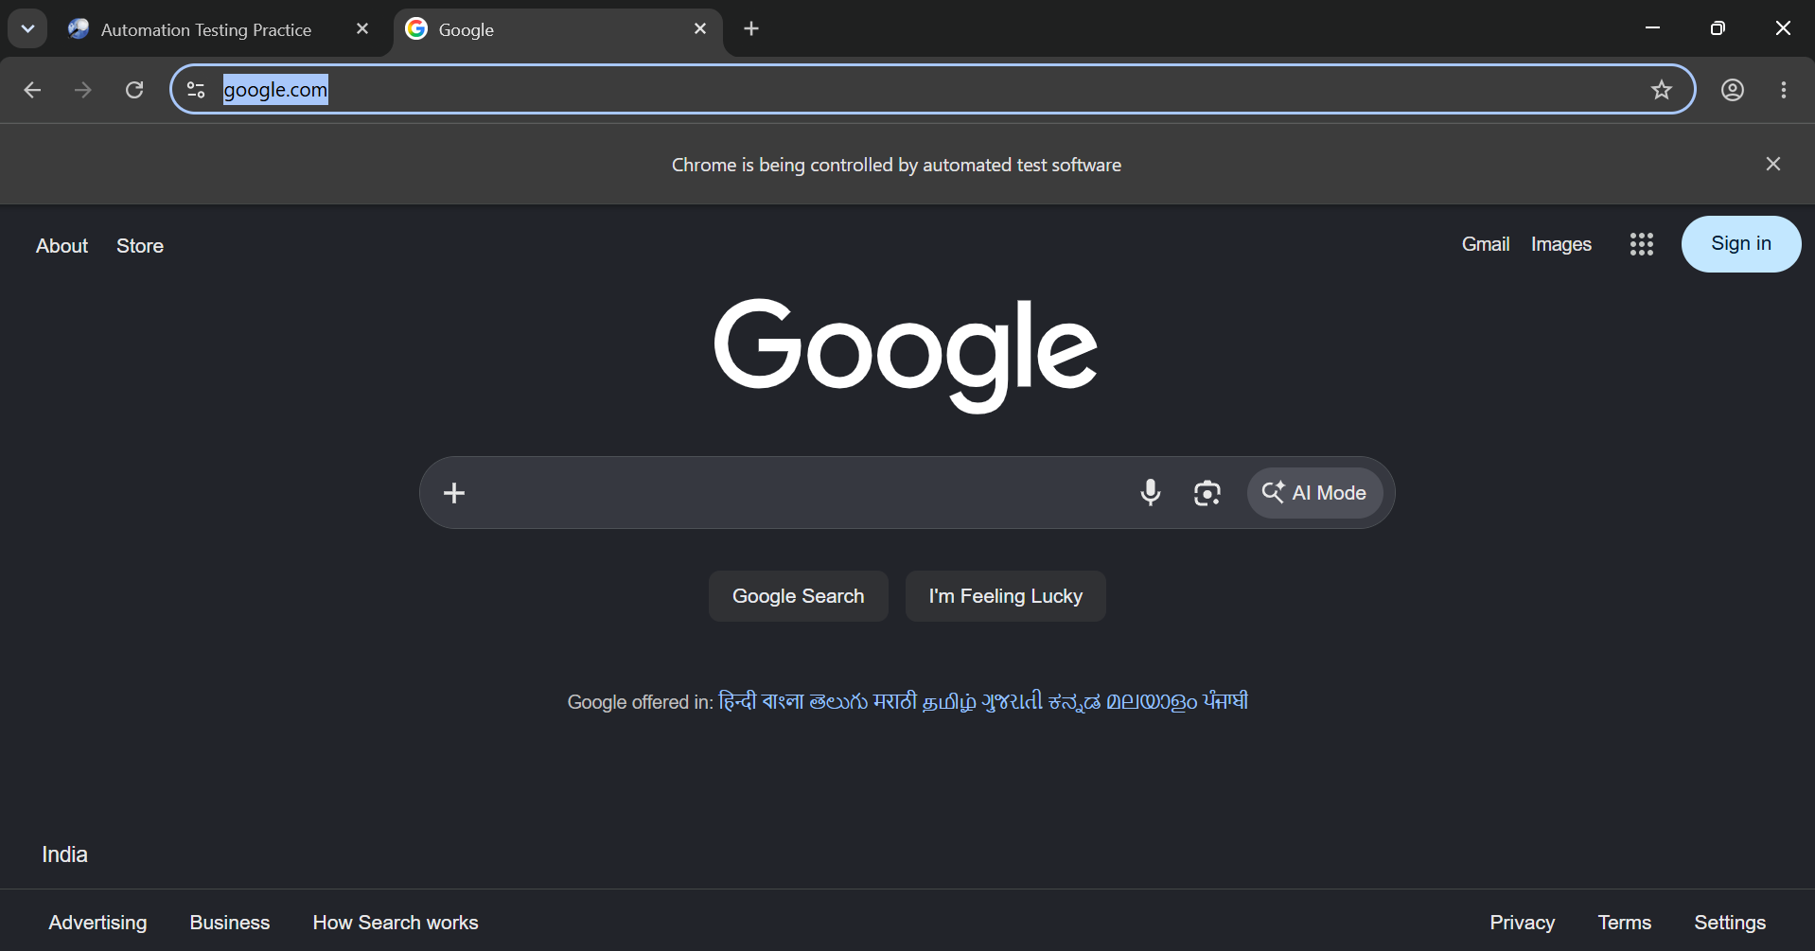

CAPTURING SCREENSHOT
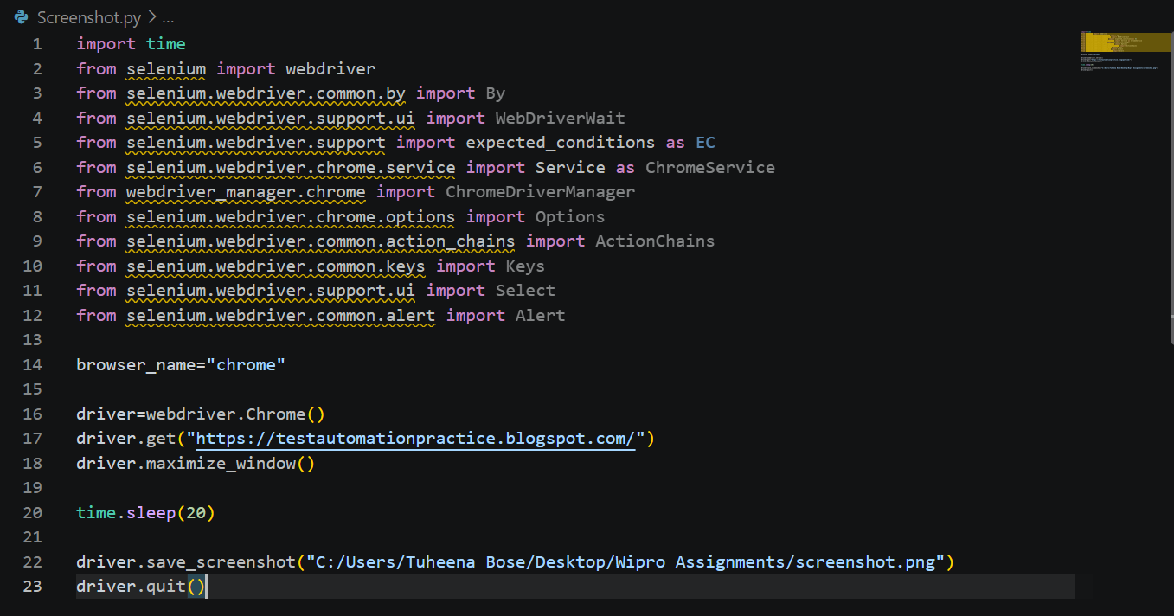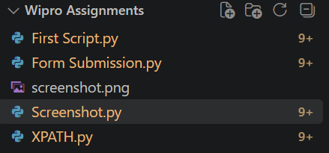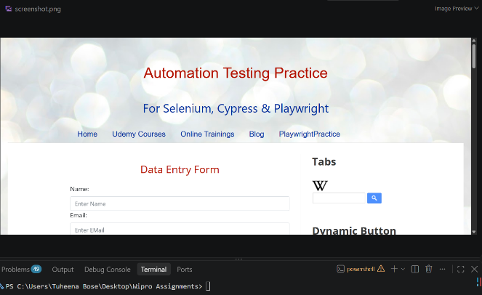

DRAG AND DROP
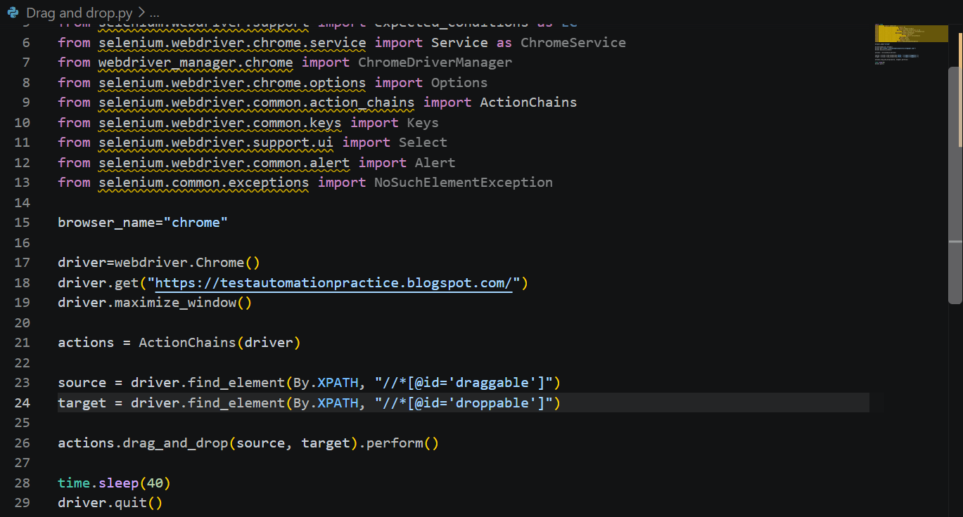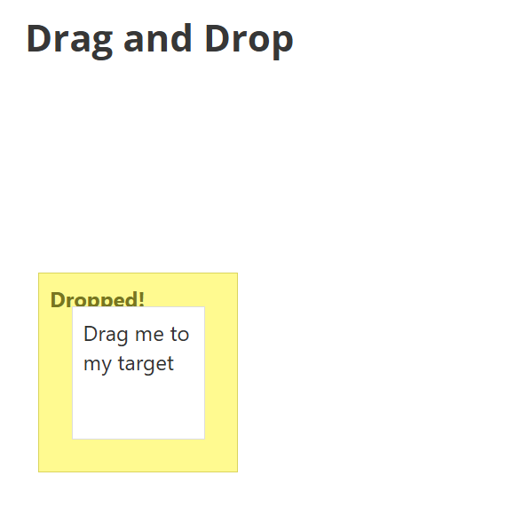

LOGIN AND PASSWORD
KEYBOARD ACTIONS
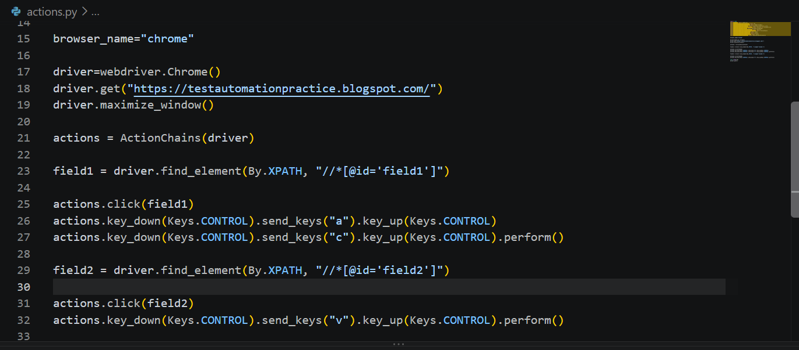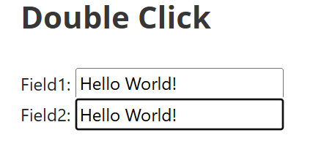

Conclusion
This module helped in further progression of automation through various browsers and create a difference among Selenium Grid and Selenium Standalone benefits and uses and also apply Selenium for more automation uses as well.

